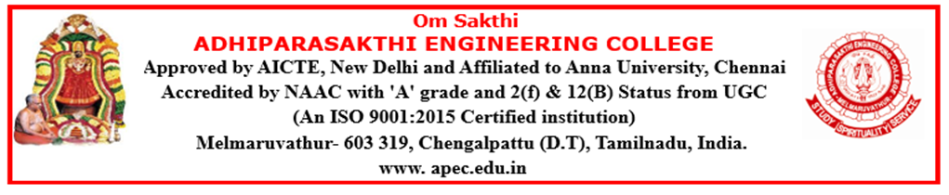

DEPARTMENT OF INFORMATION TECHNOLOGY
NEWS LETTER
The Times of Neural APEC
2026-2027

The Department of Information Technology is committed to fostering academic excellence by delivering quality education, promoting innovative learning, and providing industry-oriented training. During the academic year 2026–2027, the department successfully organized a wide range of technical events, value-added courses, workshops, seminars, guest lectures, industrial interactions, and hands-on training programs. These initiatives enhanced students' technical knowledge, practical skills, problem-solving abilities, and professional competencies, preparing them to meet the evolving demands of the IT industry and contribute effectively to society.
DEPARTMENT ACTIVITIES
VALUE ADDED PROGRAM
Duration | Topic | Duration in Days | Details of Training Partner | Class
08/07/26 to 21/07/26 | Data Analytics Using Python | 10 days | B.Ezhilavan | II YEAR
08/07/26 to 21/07/26 | Hands-on Data querying | 10 days | S.Dhivya | III YEAR
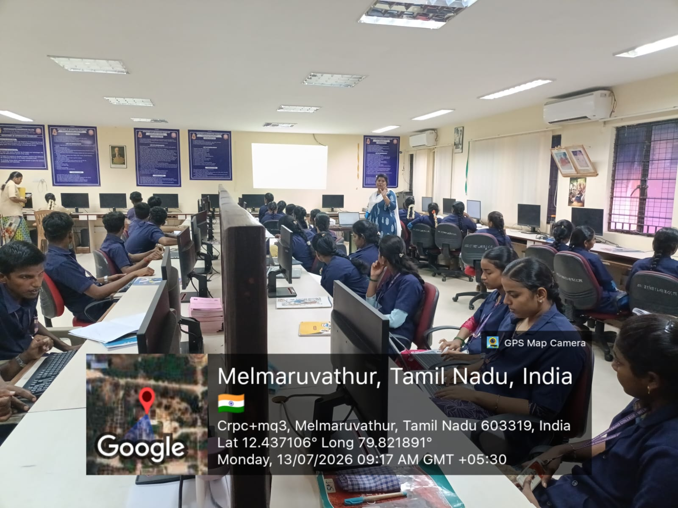
III –YEAR IT TRANING HANDS-ON DATA QUERYING ON 08-7-2026 TO 21-07-26
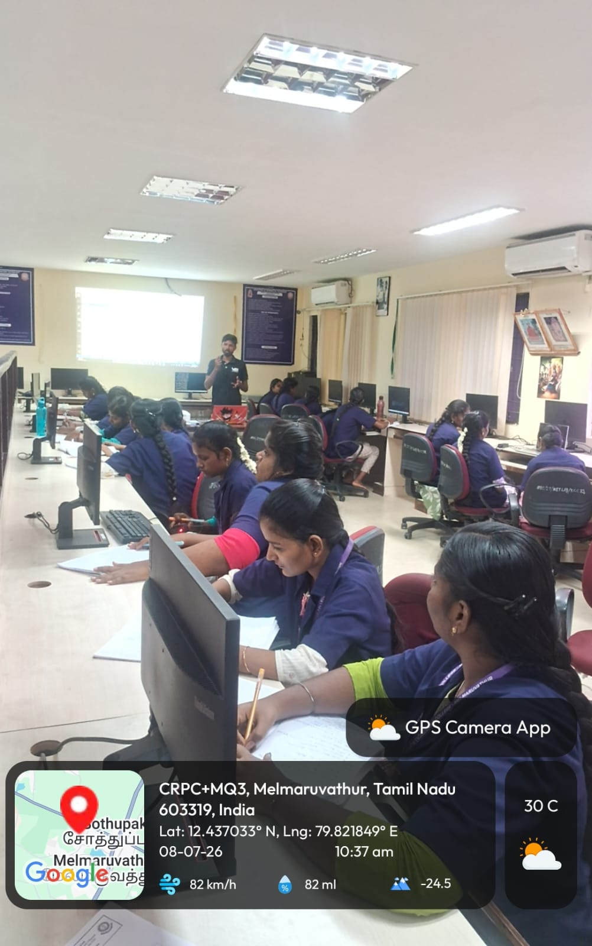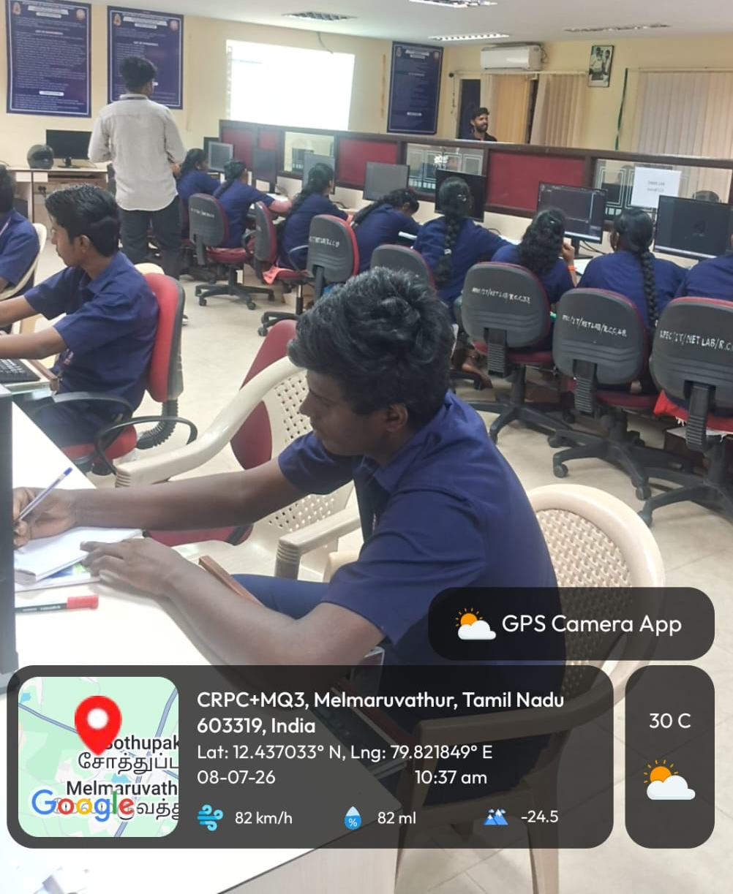
II –YEAR IT DATA ANALYTICS USING PYTHON ON 08-7-2026 TO 21-07-26
The Department of Information Technology organized a Value Added Course on "Hands-on Data Querying and Data Analytics Using Python" for students. The course was conducted from 08.07.2026 to 21.07.2026 in the Network Laboratory. It focused on teaching students how to write SQL queries, manage databases, analyze data, and create visualizations using Python. The sessions included both theoretical concepts and practical hands-on activities. Experienced trainers guided the students throughout the program, helping them gain real-world technical skills. The course successfully enhanced students' knowledge and prepared them for industry requirements.
GUEST LECTURE
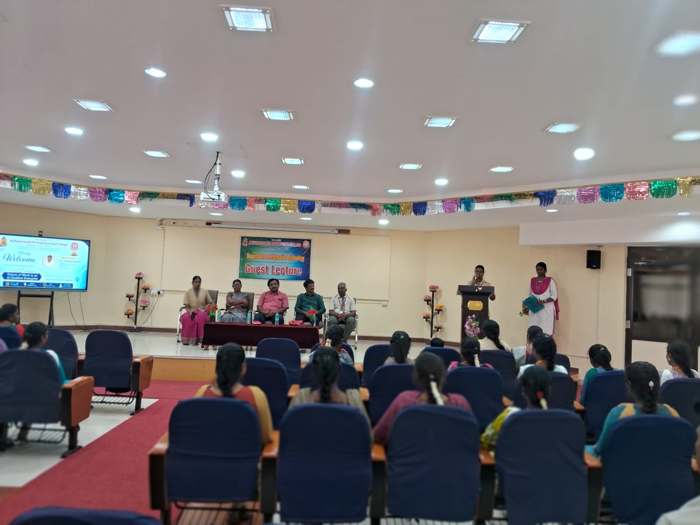

Guest Lecture on "Future of Work in an AI Enabled Enterprise" on 18-07-26
The Department of Information Technology, in association with the APEC ACM Student Chapter, successfully organized a Guest Lecture on "Future of Work in an AI Enabled Enterprise" on 18 July 2026 at the Seminar Hall, Central Library. The session was delivered by Mr. Pradeep Kabirdas, Dy Director, Software and Systems Power Division, Valeo India Pvt. Ltd., Chennai.
The resource person shared valuable insights into the rapidly evolving role of Artificial Intelligence (AI) in modern enterprises. He explained how AI is transforming industries through automation, intelligent decision-making, data analytics, and digital innovation. Students were introduced to emerging technologies, current industry trends, and the essential technical and professional skills required to build successful careers in the AI-driven workplace.
The session was highly interactive, with students actively participating in discussions and clarifying their queries regarding AI applications, future job opportunities, and career development. The lecture provided a clear understanding of the impact of AI on the future workforce and motivated students to enhance their technical competencies through continuous learning and innovation.
PARENTS MEETING
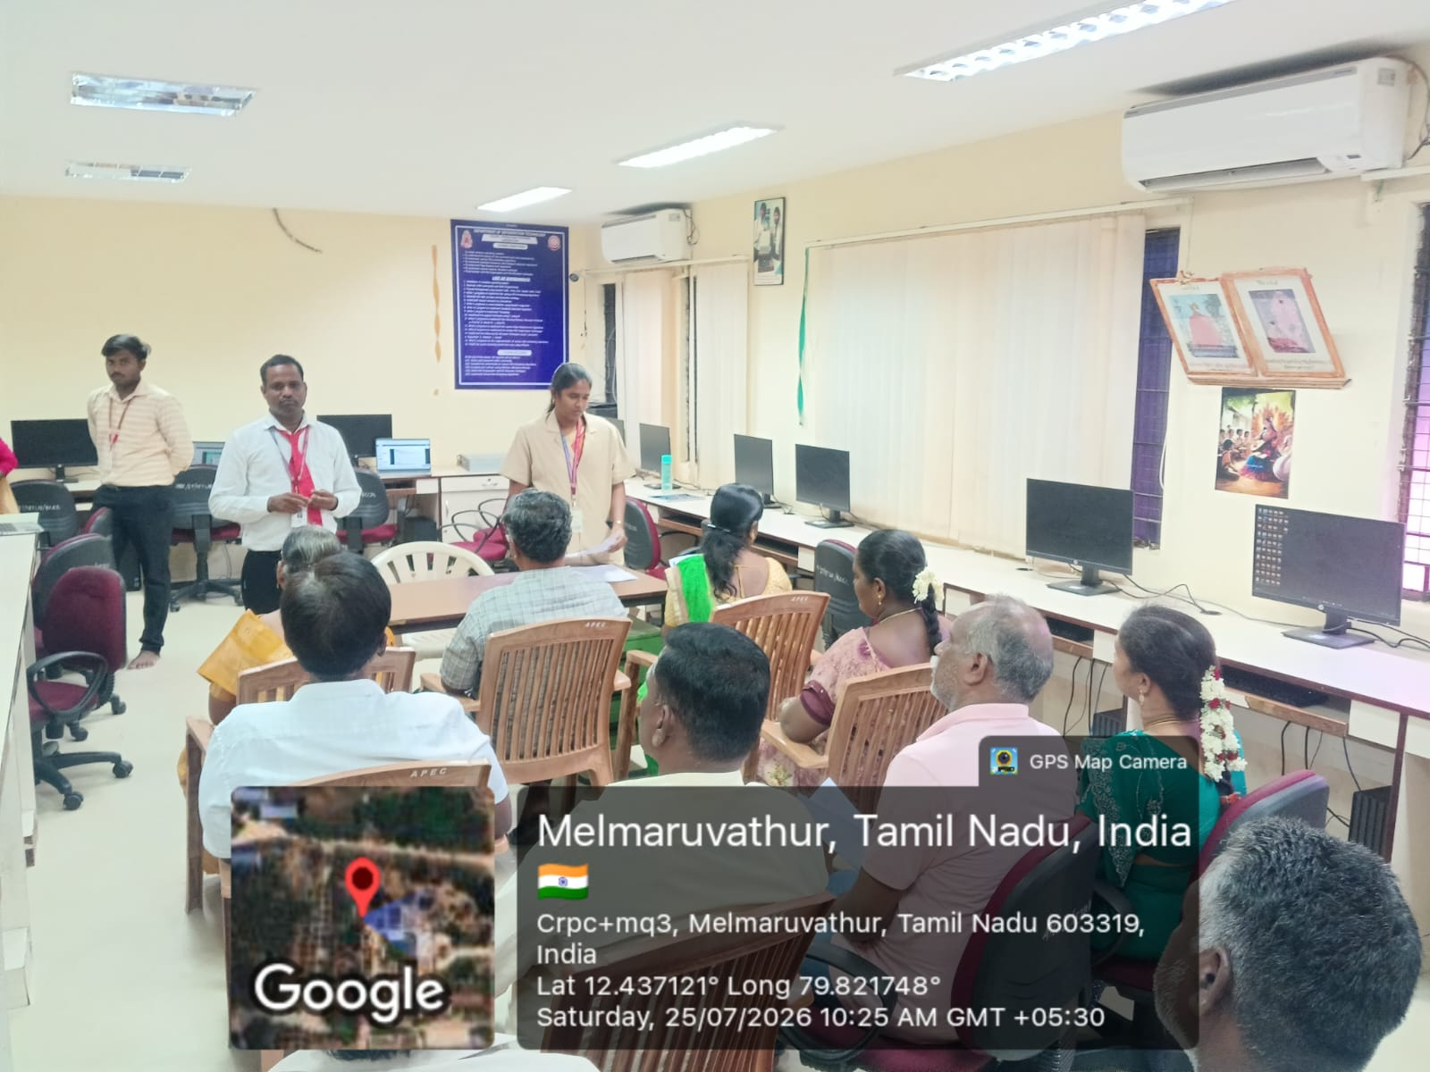
II- Year Parents Meeting on 11-07-26

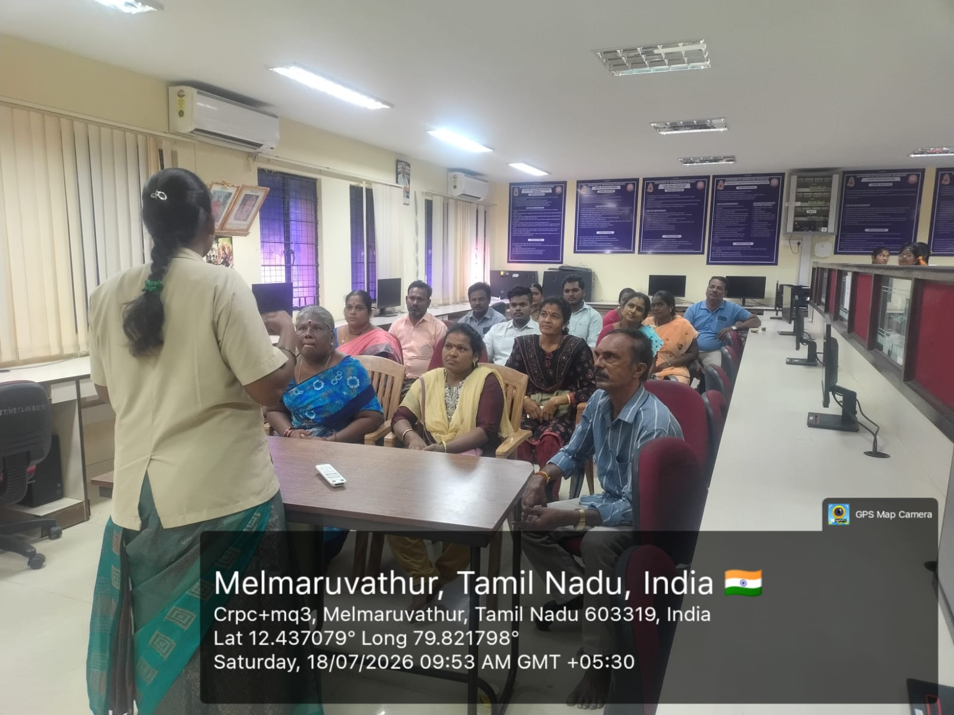
III- Year Parents Meeting on 18-07-26
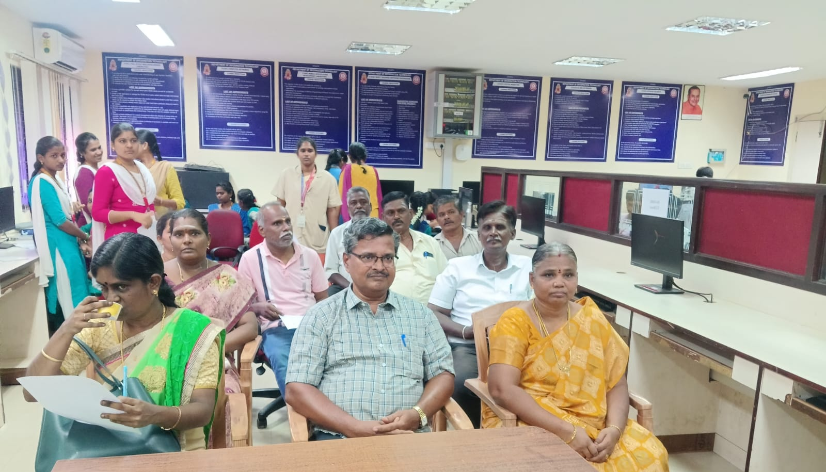
IV- Year Parents Meeting on 25-07-26

INDUSTRIAL VISIT

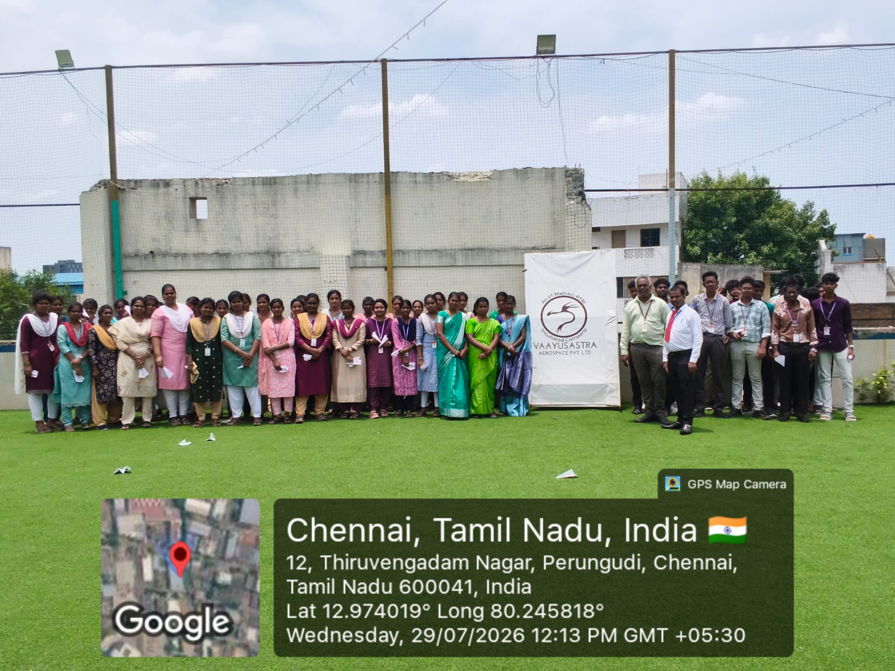
Industrial Visit to Vaayusastra Aerospace Pvt. Ltd., Perungudi, Chennai (II Yr)
The Department of Information Technology organized an Industrial Visit for the II Year B.Tech Information Technology students on 29th July 2026 to VAAYUSASTRA Aerospace Pvt. Ltd., Perungudi, Chennai. The visit was arranged to provide students with practical exposure to the latest technologies and industrial practices in the aerospace sector.
During the visit, the experts from the organization introduced the students to the fundamentals of Aerospace Engineering, Unmanned Aerial Vehicles (UAVs), Drone Technologies, Artificial Intelligence, Automation, and Embedded Systems. The students gained valuable insights into the design, development, testing, and real-time applications of aerospace products and intelligent systems.

